
School of Health & Life Sciences (SHLS)
Science Department
MSc dissertation
Project title: Gene Expression Signature as Biomarkers for Cancer Detection: A Predictive Model approach

Student name, ID, and email: Zeshan Haider Raza, C2726269, C2726269@live.tees.ac.uk
Project supervisor name and email: Dr Cassy Ross, c.ross@tees.ac.uk
Module & module code: Life Science Research Project (LSRP) & SCI4013-N
Module leader: Mohammad Dadashipour
Your course title and academic year: MSc Bioinformatics (With Advanced Practices)
Date of submission: 06-01-2025
Word count: 8378
Declaration of Generative AI Use
- I DID use Generative AI technology in the development, writing, or references of this assignment (answer questions 1-4 in an appendix).
Author Biography
I am student at the renowned institution, Teesside University Middlesbrough, UK studying MSc Bioinformatics. I did my bachelor’s in animal sciences with major of Animal Genetics. My expertise is in Molecular genetics and Bioinformatics tools.
Current degree made me expert in Machine Learning, Prediction Models and Data Analysis.

Contents
Title 1
Abstract 3
1. Introduction 4
1.1 Background 4
1.2 Problem Statement 18
1.3 Research Objective 18
1.4 Research Questions 18
2. Methodology 19
2.1 Exploratory Data Analysis 19
2.2 Prediction Model Development 20
3. Results 21
4. Discussion 26
5. Conclusion 27
References 28

Abstract

Cancer is the most prevalent disease globally. As per WHO, it is a primary/ secondary cause of death. One of the major factors that is increasing its mortality rate is its late diagnosis. Thus, this study aimed to develop a predictive model that can help to diagnose cancer early. The study combined four machine learning algorithms named: Logistic Regression, Random Forest, Gradient Boosting ensemble, and AdaBoost ensemble. The analysis of 49495 genes of 20 mouse genes showed that Random Forest showed an accuracy of 98.3%, which along with other ensembles can help to predict cancer. This study is interdisciplinary research that aims to contribute significantly to healthcare, and bioinformatics. This study can pave the early diagnosis and, also facilitate the practitioners to deploy personalized medicine to patients. It is a general model that can be changed and enhanced to detect any type of cancer gene. With the emerging significance of gene expression as a strong biomarker for cancer detection, this study offers a strong insight into the field of biology.

Science Department, School of Health, and Life Sciences (SHLS), Teesside University, Middlesbrough, UK

Keywords

Predictive model, Cancer Diagnosis, Gene Expression Signature, Data Analysis.

1. Introduction

1.1 Background
Bioinformatics is a multidisciplinary platform that uses biological data and computer methods to solve healthcare-related problems. Genomic data is the most widely used biological data in the healthcare industry. A portion of a human cell's chromosome provides information about gene expression. The expression of gene information occurs in three phases. Messenger ribonucleic acid is extracted from the human cell during the first stage, known as the isolation phase. In order to obtain complementary deoxyribonucleic acid fragments, mRNA must execute a reverse transcription-polymerase chain reaction in the second stage, known as the reverse transcription phase. The hybridization step, which is the third stage, involves labeling cDNA with fluorescent tags and introducing arrays that have hybridized with probes to express gene information (Alharbi and Vakanski, 2023).
Applying computational techniques is necessary for gene expression analysis in order to comprehend how genes are controlled or how they affect the operation of tissues and cells. In order to gain insight into how differences in genes and regulatory areas lead to phenotypic changes, including characteristics, wellness, and health, machine learning-based techniques have been widely employed (Khan et al., 2021). Deep learning-based techniques for predicting the structure and function of genomic components, including DNA promoters, enhancers, or gene sequence levels have gained popularity in the last ten years, whereas early computational methods for gene expression analysis usually relied on traditional ML approaches, such as Decision Trees and Support Vector Machines (Bhonde and Prasad, 2021).
According to the World Health Organisation, cancer is a worldwide medical problem that impacts people all over the world. According to the definition, cancer is a collection of cells that originate in certain parts of the body and frequently migrate easily to distant metastatic regions (Pati, 2018). The intricate interplay between genes, which in turn become dysregulated as a result of mutations and epigenetic changes, and the environment (carcinogens) leads to abnormal cell development. As a result, whole-genome expression profiling has emerged as a crucial technique for locating pertinent genes that are abnormal and cause aberrant cell division and metastases (Khalsan et al., 2022).
The World Health Organisation reports that in 2015, cancer was the primary or second major cause of death in most countries before 70 years of age (Paschke et al., 2018). By 2030, it is predicted that the number of new cancer cases and deaths from cancer will reach 21.4 and 13.2 million annually, respectively (Nagtegaal et al., 2019). In the United Kingdom, there were almost 375,000 cancer cases reported in 2017 accounting for lung cancer being the highest followed by breast cancer. Although the early diagnosis and treatment increase the chances of survival. However, by 2035, there is a 40% rise in cancer cases projected (Henson et al., 2020). Globally, the incidence and death rates of cancer are rising quickly. Although the causes of these increases are numerous, they mostly originate from population expansion, aging, and alterations to the primary risk factors for cancer, many of which are linked to economic and social growth. One of the key factors in rising cancer is a sedentary lifestyle, with having 13% higher risk of cancer (Park et al., 2020). According to GLOBOCAN 2020, about 19.3 million new cases and about 10 million deaths from the disease in 2020, cancer is a serious worldwide health problem. In Africa, where the risk of cancer death for women is on parity with that of high-income nations, this burden is substantial across all areas and developmental levels. It is imperative to make investments in cancer prevention and care infrastructure, especially in poor nations, in order to effectively deal with this issue (Sung et al., 2021).
According to estimates from the International Agency for Research on Cancer, there are over 10.0 million cancer-related deaths and 19.3 million new cases of cancer in 2020, making cancer one of the major causes of death globally. 28.4 million additional cancer cases are anticipated globally in 2040, representing a 47% rise (Sung et al., 2021). The majority of advanced malignancies are deadly despite tremendous efforts and advancements in cancer treatment techniques, such as electromagnetic radiation, new chemotherapeutics, and targeted biological agents utilized as standards of treatment. The primary cause of this is treatment resistance, which many tumors either naturally possess or have developed over time. The impact of the tumor’s microenvironment is one of the interrelated mechanisms that regulate treatment resistance (De Vries et al., 2020).
Moreover, when using bulk cancerous tissue for research, cellular heterogeneity a significant concern in cancer studies is not clear. Any organism's basic building block is a single cell, whose activity is determined by a combination of environmental and genetic influences. Early on, scientists concentrated their efforts on studying cancer at the molecular level (Bhonde and Prasad, 2021). At first identified cancer as a disease of mutant cells displaying unchecked proliferation and invasiveness in the 1850s, after learning that cancer cells originated from healthy cells. Cancer research was greatly aided in the 1980s by substantial improvements in our knowledge of cell processes. These investigations have produced hitherto unheard-of insights into the mechanisms of resistance, driver genes, and the course of cancer (Azizan et al., 2024).
Any detectable molecular predictor of cancer risk, cancer incidence, or patient outcome is referred to as a molecular cancer biomarker. Proteomic signatures, transcriptional alterations, epigenetic signatures, and germline or somatic genetic variations are a few examples. Based on biomolecules like proteins and nucleic acids, these indications can be found in tissue samples taken by tumor biopsy or, in a simpler and non-invasive manner, in the blood (or serum or plasma) (Poon et al., 2021) saliva, buccal swabs, faces, urine, etc. Over the past few decades, there has been a significant advancement in detection technologies, including approaches to analyze circulating tumor DNA/RNA or exosomes, nanotechnology, and next-generation sequencing. There are several clinical uses for biomarkers. They can serve as instruments for evaluating the risk of cancer, screening for and detecting cancer early, making precise diagnoses, and determining the prognosis of patients (Mattox et al., 2022).
As a result, they may aid in improving clinical practice decision-making. Furthermore, since recently developed targeted medicines only work in people with certain cancer genetic mutations and biomarkers are the instruments used to identify these patient subsets precision oncology is required. To solve the scientific obstacle of creating novel biomarkers with higher sensitivity, specificity, and positive predictive value, however, advancements in the field of cancer biomarkers are required (Sarhadi and Armengol, 2022).
The most common methods of cancer detection from an early age are different imaging methods including magnetic resonance imaging, positron emission computed tomography, computed tomography, and single-photon emission computed tomography (He et al., 2020), endoscopy, blood and tumor marker tests, cytogenetic techniques, and biopsies. Ultrasonography is used to locate the cancer cells and is suitable for human beings. However, this method of imaging has low resolution and can’t differentiate between cancer and non-cancer cells. Moreover, it is not preferred for small cancer masses. Magnetic resonance imaging is mostly preferred for early cancer diagnosis and is the most prevalent cancer detection method (He et al., 2020). However, its high cost and less imaging time make it difficult to comprehend the cancer diagnosis. Computed Tomography is an additional cancer detection method but it has poor spatial resolution and results in normal cell damage (Chen et al., 2024). SPECT, is used for high spatial resolution of cancer cells and is most recommended for cells that undergo metastasis. However, it is not recommended for inflammatory and metabolic aberrations (Wang et al., 2024b).
Nanotechnology is being widely used in cancer detection but at an early stage. It addresses the traditional cancer treatment methods at the molecular level. Different methods including nanoprobes, nano biosensors, and quantum dots are improved and advanced technologies for biomarker profiling (Alshehri et al., 2020) Nano biosensors are used to identify small cancer masses using receptors, transducers, and signal processors. It uses electrical and optical signals for cancer detection. It is widely deployed in breast, lung, and colon cancer detection (Taha et al., 2024).
Nanoprobes use optical and magnetic signals for high surface area to volume cancer cells. It is usually integrated with MRI, PET, and fluorescence imaging for précised cancer identification. Nano particles are used for the detection of cancer biomarkers and also penetrate deeper into the cancer cells (Chaudhuri et al., 2023). It is a good intervention in the cancer detection field ensuring enhanced cancer detection. Moreover, quantum dots are also being used for highly sensitive cancer cell detection. It is also being integrated with AI to ensure successful cancer detection (Adir et al., 2020).
Liquid biopsy is another method used for the diagnosis of cancer. It is a biomarker identification of cancer cells from biological fluids (Galoș et al., 2022). Endoscopic cancer diagnosis is also recommended for use in gastric cancer identification. However, it is used at early cancer diagnosis but at later advanced levels, it is not recommended (Leja et al., 2021). Currently, a cancerous tumor is believed to as a microenvironment where cancer cells, immune cells, stromal cells, and non-cellular tissue components may all adapt and change in response to changes in the environment. In health care, machine learning has ignited a lot of interest, especially in the areas of medical image analysis, disease detection, and e-diagnosis. For more than 50 years, traditional statistics have dominated health research, but data scientists from a variety of sectors have been using machine learning extensively (De Felice and Polimeni, 2020). Calculating sample size, probability distributions, and hypothesis testing are examples of common conventional statistical analyses. Machine learning, on the other hand, is concerned with classification, decision trees, variable significance, model assessment, and prediction analysis. The healthcare industry is still hesitant to embrace new technologies and computational techniques despite machine learning's enormous promise because of concerns about machine dependability and trust. Large volumes of healthcare data, including administrative, clinical, patient medical history, lifestyle, and personal data, are produced, making it impossible to handle their analysis using simple statistical software tools (Çinar et al., 2020).
This calls for sophisticated apps with affordable, high-end processing power.
To improve prognostications, anticipate health hazards, enhance diagnostics and treatments, and create long-term care plans, automated solutions are required. The development of machine learning and traditional statistics in health research is essential to determining whether they are entirely distinct from one another or connected. Beginning with the introduction of mathematical ideas in the early 17th and 18th centuries, conventional statistics have a history spanning more than 50 years as shown in Figure 1. Advanced software tools were developed as a result of the prioritization of the use of processing capacity in statistical analysis. Since its introduction in 1952, machine learning has developed into deep learning and is currently the foundation of artificial intelligence (Nabipour et al., 2020, Odabaşı et al., 2020).
As high-throughput next-generation sequencing technologies have grown in popularity, omics techniques such as transcriptomics, proteomics, radiomics, and genomics have continuously taken the lead in contemporary biological and medical research. To assess the particular kind of biological components, the majority of early research employed single omics, which might provide erratic biomarkers that vary in rank among omics kinds (Chen et al., 2023a). High-quality critical biomarkers, as well as molecular pathways and regulatory networks causally linked to illnesses, may be found by the so-called multi-omics, which combines many types of omics, thanks to the advancements and cost-effectiveness of omics. In order to examine the illness-specific variations a standard multi-omics study would compare disease samples with controls and samples with varying severities or progressive phases (Chu et al., 2021).
A rare chance to fully exploit state-of-the-art artificial intelligence techniques, such as machine learning and deep learning, to gain expertise in interdisciplinary research fields is presented by the combination of demographic and clinical data with multi-omics information collected from patients with a particular disease (Villa and Yoon, 2021). The best way to shed light on the time-dependent variable illness progression features is to combine longitudinal data with multi-omics data from the same set of samples. Because of their unique underlying molecular mechanism linking both phenotype and genotype, multi-omics could detect groups of patients with diverse endotypes demonstrating variable treatment responses for complex and multidimensional disorders (Virzì et al., 2019).
The results of Mohammadi-Shemirani et al. (2023) may help with early diagnosis, prognostic prediction, and the use of the best and most efficient treatment plans for the illness, improving patient quality of life and enabling personalized medicine. The study of human illnesses, including cancer, uncommon disorders, and other common diseases, has recently made substantial use of multi-omics. For instance, it has been shown to be crucial in predicting how breast tumors would respond to therapy, identifying the epigenetic alterations in Alzheimer's disease patients' brains, and enhancing the clinical care and diagnostic yield of patients with uncommon illnesses (Chen et al., 2023a).
Conventionally cancer is treated by surgery, radiotherapy, and systemic chemotherapy (including hormonal therapy and molecular targeted drugs). The type and stage of the cancer, the patient's age, and general health all influence the therapy selection. These traditional treatments work well for confined tumors in their earliest phases, but they are less successful for cancer in its later stages, and recurrence is more expected (Sharma et al., 2017). Currently, 90% of chemotherapy failures occur during the invasion and spread of drug-resistant tumors, suggesting that drug resistance is a significant issue in cancer treatment. Despite the injection of a certain prescription during chemotherapy, many patient cancer cells become resistant to drugs (Siegel et al., 2021).
Through a variety of mechanisms, including drug inactivation, epigenetics, drug-gene alteration, drug efflux, DNA damage repair, cell death inhibition, and epithelial-mesenchymal transition, many cancer types can eventually become resistant to conventional therapies, even though they are initially susceptible to chemotherapy (Glatzer et al., 2020). Through a variety of signal transduction channels and working alone or in concert, these processes either directly or indirectly increase drug resistance in human cancer cells. According to a study by Sharma et al. (2017), medications that target these signaling pathways may become resistant due to mutations in the self-controlling negative feedback in signal transmission (Sharma et al., 2017). Additionally, tumor cells could not have antigenic mutations or might not have some essential immune system components, such as Human leukocyte antigens, which might make them resistant to immunotherapy medications. Moreover, a lot of the chemicals used in conventional therapies harm both healthy and malignant cells, which might have detrimental consequences. In addition, these conventional cytotoxic treatments do not specifically target tumor cells, making them ineffective for providing long-term cancer prevention (Damyanov et al., 2018).
Due to ongoing breakthroughs in technology and our understanding of the disease, the diagnosis of cancer is changing quickly, making accurate diagnostic methods more feasible. Implementing positron emission tomography, magnetic resonance imaging, single photon emission computed tomography (Sung et al., 2021), computed tomography, X-ray imaging, and analysis of molecular signatures of cancer cells, there are a number of cancer diagnostic modalities that can be used to diagnose and treat cancer. Although there are strategies and methods for assessing related risk and tracking the therapy response, the clinical and cost efficiency of various cancer diagnostic modalities is lacking (Medina-Lara et al., 2020).
However, the application of machine learning in cancer gene expression identification is growing because it can get beyond the limitations of conventional techniques. Feature selection algorithms and dimensionality reduction are two ML techniques that are capable of handling complex data and finding biomarkers and important patterns. By overcoming their inherent drawbacks, machine learning (ML) outperforms existing medical techniques for detecting cancer gene expression, including immunohistochemistry, polymerase chain reaction, and next-generation sequencing (Villegas-Ch et al., 2020). IHC and other conventional medical methods rely on visual evaluations and single-marker detection, which might result in arbitrary interpretations and limited understanding of intricate gene interactions. Despite being extremely sensitive, PCR and NGS mostly offer raw data without strong interpretive frameworks, necessitating either pre-established statistical models or a great deal of human processing (De Felice and Polimeni, 2020).

Although multi-omics integration has demonstrated strong performance in the molecular characterization of human illness etiology, the diverse phases of development of various omics approaches have made data collecting, analysis, and harmonization extremely difficult. Specifically, compared to other mass spectroscopy-based omics types like proteomics and metabolomics, sequencing-based transcriptomics has more well-established and standardized pipelines for both experimental and bioinformatic procedures. Additionally, although proteomics may only search for certain genes, transcriptomics can encompass all human genes that code for proteins (Chu et al., 2021).
AI is a field within computer science that is moving rapidly towards applications across different sectors. The creation of intelligent computers that are programmed to function and behave similarly to humans is also referred to as artificial intelligence. AI, a technique that allows the computer to understand the facts and then make a forecast, has been employed to expand and improve a broad number of fields and industries, most notably healthcare (Alloghani et al., 2019).
In Addition, applications for machine learning techniques are numerous and range from helping healthcare professionals with tasks like MRI image identification and genomic data analysis, and its forecasting. The field of cancer research has seen a significant transformation due to the increase in computer use. Early research conducted in 2000 showed that artificial intelligence approaches may be used and used in healthcare databases. Numerous gene expression measurement data sets have been produced by the use of DNA microarray investigations. Sorting the samples into established categories is a crucial process when dealing with gene expression data (Arora and Tollefsbol, 2021).
Additionally, by developing a machine learning model to identify cancer or healthy tissue, the data may be usefully processed to uncover obscure trends and choose meaningful characteristics. Filter and wrapper gene selection are the two feature selection methods used in DNA microarray and gene expression data. The filter approach is often applied during the data preparation stage. There are no AI algorithms that affect the step. Based on statistical methods, the informative features also known as informative genes are chosen (Zielinski et al., 2021).
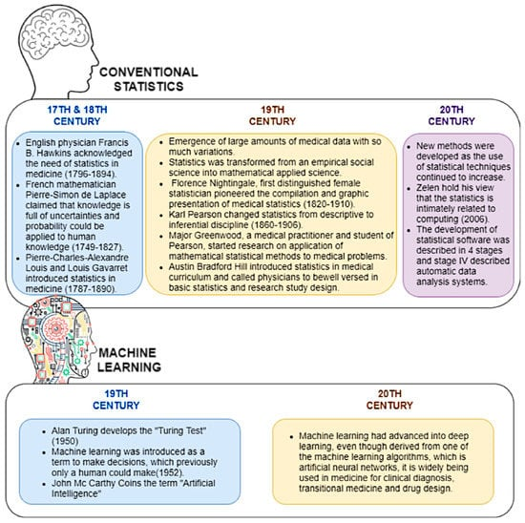
Moreover, the gene expression data is filtered using the results of statistical tests like ANOVA, t-test, and Pearson's correlation. This may increase the categorization accuracy of cancer. The technique known as wrapper gene selection, on the other hand, trains the algorithm using a subset of characteristics. The practitioner's judgement determines whether to include or exclude a

Figure 1 Evolution of Machine Learning in Cancer Treatment (Dhillon et al., 2022)
characteristic from the subset. However, this approach reduces a search issue and is computationally costly. Additional cutting-edge assessments of feature selection methods are available in (Avanzo et al., 2021). Cancer has always been a persistent, and erratic disease with
Poor prognoses are based on the anatomical location and stage. Accurate and primary cancer detection is thought to be crucial for accurate disease prognosis, patient survival, and therapy. Early identification of cancer requires knowing who is at higher risk of developing the disease in the near future. AI, ML, and strengthen the art of predicting the possibility of developing cancer. All of these computerized systems provide predictions, diagnoses, or a prognosis of the malignant sickness based on information such as a patient's medical history, investigations, scans, and other data (Samala et al., 2018).
AI has increased in prominence for predicting clinical prognoses, especially in cancer. To forecast the onset and spread of brain cancer, clinicians employ artificial intelligence (AI) tools such as machine learning and deep learning as shown in Figure 2. With convolutional neural networks demonstrating remarkable performance in diagnosing clinical images as well as patient histories and sequences, machine learning and deep learning have greatly enhanced cancer diagnostic models. The growth of high-quality data sources and improved algorithms has led to the adoption of these technologies in therapeutic settings (Chen et al., 2023b). The use of these technologies is still in its infancy, though, due to issues with algorithm bias, data protection, and the need for experimental validation. Improved diagnostic capabilities with more precision, fewer bodily intrusions, and quicker treatment of illnesses found are the goals of these technologies. It is essential to address these issues as research in this area progresses to make sure that these contemporary solutions to cancer diagnosis (Delli Pizzi et al., 2021).
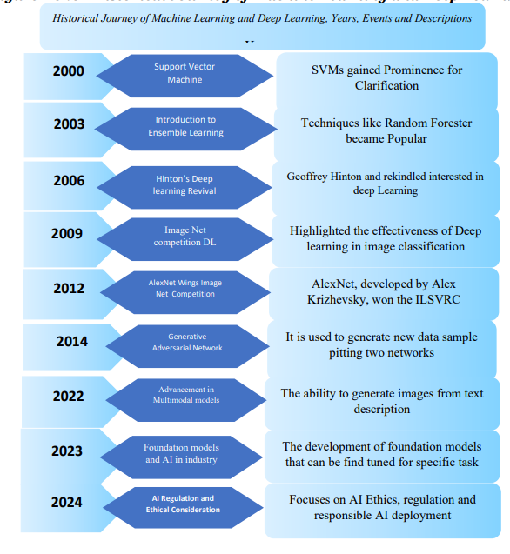
Figure 2 The evolution of Machine Learning and Deep Learning in cancer detection (Khandakar et al., 2024).
Moreover, the prognosis of patients can affect treatment options and results, and traditional statistical analysis is unreliable in forecasting the course of cancer. AI can better accurately estimate prognosis, patient survival (Huang et al., 2020), and illness progression by analyzing and comprehending multi-factor data from patient assessments. Scientists frequently employ multi-modal deep neural networks in breast cancer prediction to forecast patient survival and assess the chance of the disease reoccurring, which improves therapy. This method collects DNN approaches and combines several kinds of data to enhance human breast cancer prognostic estimates (Sebastian and Peter, 2022).
One of the main issues that academics are dealing with is the machine learning analysis of NGS datasets. Gene Sequencing is making cancer prediction a more reliable and efficient method. Understanding the intricate details of biological systems has been made easier by next-generation sequencing. It has offered a more accurate, cost-effective, and efficient method. The paradigm change in cancer studies has been initiated by the discovery of microRNAs, sometimes referred to as tiny non-coding genes. Gene classification and grouping using statistical methods are an aspect of microarray data analysis. In addition to statistical methods, microarray data analysis also makes use of machine learning strategies including Random Forests, Decision Trees, Neural Networks, and Support Vector Machines (Disney et al., 2020).
When it comes to the practical use of proven multi-gene prognostic methods, breast cancer is now the most successful field, and genomic panels have a discernible influence on BC care. Five multi-gene panels (Oncotype DX, MammaPrint, Endo Predict, Prosigna/PAM50, and the Breast Cancer are regarded as stage modifiers in the 8th edition of the American Joint Committee on Cancer's 2017 update to the cancer staging manual (Giuliano et al., 2017) This reclassifies low-risk hormone receptor-positive, and lymph node-negative tumors of any size into Stage I, the same prognostic category. By comparing gene expression data from patients who experienced recurrences and those who did not, several gene expression signatures in breast cancer could be experimentally identified in the early 2000s because of the introduction of gene expression profiling techniques (Qian et al., 2021).
Oh et al. (2019) have studied the use of the ANN model for successful diagnosis of gastric cancer. ANNs have been shown to be more successful than Cox proportional risk regression models in predicting the prognosis of gastric cancer. The results were almost associated with real survival, and survival was predicted using a survival recurrent network (SRN) model (Oh et al., 2019).
Moreover, with the advent of technology, cancer detection via genomic profiling has become a great option for cancer detection. It can help to identify the subtype of the tumor to help in cancer treatment. (Chakravarty and Solit, 2021). Radio-genomic is another method for cancer profiling at the molecular level. The key difference between radio-genomics and imaging data is the crucial knowledge gap that exists between tissue-level imaging and the analysis of underlying genetic and molecular disease biomarkers. Imaging can result in either too much or too little therapy since it is less accurate. Despite being far more effective than histopathological imaging, radio-genomics is rarely employed due to the high processing power and cost of the information involved (Nassif et al., 2022).
Traditional assays like fluorescence in situ hybridization and immunohistochemistry are essential precision medicine tools in everyday practice, and they are now used to detect a large number of biomarkers. IHC may identify protein-level alterations brought on by particular DNA rearrangements or point mutations such as specific EML4-ALK translocation in non-small cell lung cancer and the IDH1/2 mutations in gliomas) (Lateef et al., 2018) in addition to gene aberrations, most often gene amplifications. The application of IHC has expanded to include biomarkers of response to immuno-oncology (IO) drugs, such as mismatch repair status or PD-L1 expression, which establish eligibility for anti-PD-1/PD-L1 agent-based treatments in certain tumor types. The gold-standard method for identifying DNA rearrangements is FISH, which is also frequently used to validate gene-level amplifications in cases when IHC results are unclear (Poveda et al., 2017).
NGS technology has progressively replaced traditional methods, such as single-gene testing, and targeted mutational platforms in routine molecular pathology as the number of druggable gene aberrations and predictive biomarkers in cancer increases. When it pertains to finding variants linked to drug resistance or actionable mutations that have been shown to benefit from matching targeted medicines (Pai‐Scherf et al., 2017) conventional approaches offer good sensitivity and specificity. However, these methods require a specially designed assay for every analyte and require each biomarker to be pre-specified in order to be identified. A wide range of genomic changes, including mutations, copy number variations, translocations, and gene fusions, may be analyzed by NGS (Poveda et al., 2017).
Thus, compared to repeated single-biomarker studies, NGS analysis offers a more effective, economical, and tissue-saving cancer analysis, especially when considering the genetic complexity known to reside inside malignancies. Comparing NGS performance to single-gene testing, reverse transcriptase (RT)-PCR-based targeted mutation platforms, and other traditional methods, several studies have demonstrated comparable sensitivity and specificity in identifying frequent druggable genomic abnormalities in everyday life (Massard et al., 2017).
Heitzer et al. (2019) analyzed and found that NGS can be utilized to detect cancer. NGS can analyze the full tumor genome, including the intronic sections (whole genome sequencing (WGS)), concentrate on the coding portions of every base pair in the genome, or be restricted to a pre-specified set of genes. The ultimate use of malignancy testing, the necessary outcomes, technical effectiveness, and cost are some of the variables that influence the decision between various methods (Heitzer et al., 2019).
Numerous researchers have developed various approaches for classifying malignancies using microarray data. These methods range from machine learning techniques to statistical methods for classifying tumors. The problem of excessive dimensionality in data is avoided by microarray data. This problem is addressed by feature selection algorithms (Ahluwalia et al., 2021). Model training time is decreased by the elimination of superfluous features through the application of feature selection techniques. Two limitations that limit the functionality of conventional feature selection methods are scalability and generalization. Deep Neural Networks may be used to create scalable and generalized models as well as automate feature extraction. The development of DNA-microarray technology has significantly advanced bioinformatics research (Wu et al., 2020). Gnomonic data is being simultaneously screened by scientists in an effort to uncover hidden patterns that may aid in drug discovery. Identifying gene-gene interactions, possible biomarkers for various genetic disorders, and genetic mutations or modifications are all aided by this type of parallel screening. This simultaneous screening aids in the early detection of several serious illnesses, including cancer (Fan et al., 2021).
Concerning malignant melanoma, the deadliest kind of skin cancer, the incidence of skin cancer is rising annually. Additionally, it might be challenging to diagnose skin cancer from the skin lesion as a result of poor contrast, artifacts, and comparable visualizations, such as scars or moles.
Vidya and Karki (2020) used Automatic detection for skin lesion detection using techniques for lesion detection for accuracy, efficiency, and performance criteria. For the purpose of early skin lesion identification, Vidya and Karki (2020) suggested an approach that uses feature extraction utilizing the ABCD rule, GLCM, and HOG features. In the proposed work, Pre-processing was used to to enhance the skin lesion quality and clarity to eliminate artifacts, skin color, hair, etc., Geodesic Active Contour, which divides the lesion portion independently and is more helpful for feature extraction, was used to segment the data. The symmetry, border, color, and diameter attributes were extracted using the ABCD scoring technique. Textural characteristics were extracted using GLCM and HOG. The collected characteristics were immediately fed to classifiers to categorize skin lesions between benign and malignant using different machine learning approaches such as SVM, KNN, and Naïve Bayes classifier. Skin lesion photos, including 672 images of melanoma and 328 photographs of benign lesions, were downloaded for this study from the International Skin Imaging Collaboration. Using SVM classifiers, the classification result was 97.8% accurate with an area under the curve of 0.94. Furthermore, employing KNN, the sensitivity and specificity were 86.2% and 85%, respectively (Vidya and Karki, 2020).
There are several molecular kinds and subtypes of breast cancer, making it a diverse illness. The application of precision medicine in the clinical treatment of breast cancer has been made possible by developments in genomic research. Differentiating triple-negative breast cancer, the most aggressive and deadly kind of disease, from non-triple-negative breast cancer is a vital unmet medical need. Therefore, machine learning is being incorporated at the genomic level to identify breast cancer (Allegra et al., 2020). Similarly, La Forgia et al. (2020) conducted a study deploying machine learning to identify breast cancer. For this, they selected the features employed in the creation and verification of the classification models and analyzed RNA-Sequence data from 992 non-triple negative and 110 triple negative breast cancer samples from the Cancer Genomics Atlas. In order to train the models for identifying the two forms of breast cancer, they used characteristics chosen at different threshold levels to test four distinct classification models: Support Vector Machines, K-nearest neighbor, Naïve Bayes, and Decision Tree as shown in Figure 2.
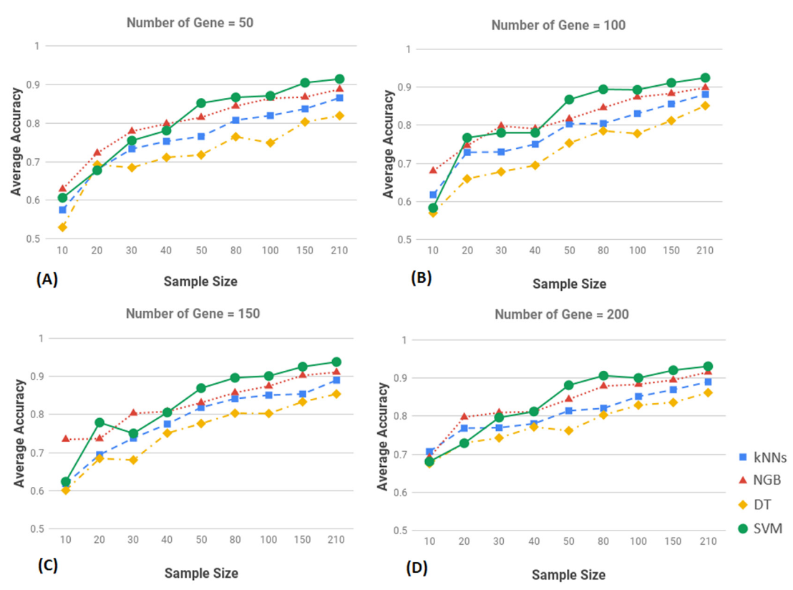
Figure 3 A study by La Forgia et al. (2020) to identify the efficacy of different machine learning methods to identify breast cancer.
La Forgia et al. (2020) suggested techniques were used on separate gene expression datasets for validation and performance assessment. They found out that out of the four machine learning algorithms that were assessed, the Support Vector Machine method had fewer misclassification errors and was better at classifying breast cancer into triple negative and non-triple negative categories. The prediction findings demonstrate the effectiveness of machine learning algorithms and their potential for classifying breast cancer into triple negative and non-triple negative forms (La Forgia et al., 2020).
Thus, the present study is being conducted to develop a predictive model using Machine Learning. This will prove to be a significant contribution to the medical field given its accuracy and help in predicting cancer. Moreover, the model is general and it can be customized to detect any cancer and genomic aberration. It will help to detect cancer at early stages, thus facilitating treatment. This research work can be used to precisely identify the cancer to design the clinical treatment. It is interdisciplinary research that can be further enhanced by introducing the drug response to the diagnostic cancer.
Moreover, these techniques are frequently laborious, have limitations when it comes to managing huge datasets, and are less successful in identifying new biomarkers or forecasting clinical outcomes. Accurate classification of cancer subtypes, prognostic forecasts, and therapy responses are made possible by the superior predictive capacity of machine learning models, particularly ensemble and deep learning techniques. Because it is data-driven and able to integrate various datasets, machine learning (ML) offers advantages in efficiency, scalability, and integration, offering a thorough understanding of cancer biology (Im et al., 2019). This all-encompassing method makes it easier to find new biomarkers and tailored treatment plans. ML models are appropriate for large-scale genomic data since they also cut down on the time and expense needed for analysis. ML improves the precision of diagnostic and prognostic tools by reducing human bias and improving cancer providing solid insights, which results in revolutionary breakthroughs in precision medicine and improves cancer diagnosis (Dogan and Birant, 2021).
Moreover, healthcare facilities have historically been dominated by conventional statistics, although machine learning has become widely used in many different sectors. Calculating sample size, probability distributions, and hypothesis testing are illustrations of common conventional statistical analyses. In contrast to that, machine learning makes use of ideas such as classification, decision trees, variable importance, model evaluation, and prediction analysis. The healthcare industry is still reluctant to embrace new technologies and computational techniques despite machine learning's enormous promise because of concerns about machine dependability and trust (Dhillon et al., 2022). Basic statistical software solutions cannot handle the vast volumes of healthcare data, comprising administrative, medical, and personal data. This calls for sophisticated apps with affordable, high-end processing power. To help biostatisticians, researchers, and doctors, these applications need to be easy to use and incorporate data protection features. Optimizing diagnosis, treatment, prognostications, predicting health risks, and long-term care planning need automated systems. It's still unclear if machine learning and traditional statistics are entirely distinct or if they are interrelated (Wei et al., 2023).
Our study aims to develop a predictive model that will advance cancer diagnosis, thus facilitating its treatment. Developing a prediction model is a scalable solution to the present cancer diagnostic methods. This model will help healthcare workers to distinguish between cancer and non-cancer genes, for timely treatments. Gene expression profiling will help differentiate normal cells from cancerous cells and is a good alternative to traditional diagnostic methods.

1.2 Problem Statement
Early and precise identification of cancer is essential to improve patient health since it continues to be a leading death cause globally. Conventional diagnostic techniques, such as imaging and tissue biopsies, frequently have invasiveness, sensitivity, and specificity issues that lead to delayed or undesirable diagnosis. These difficulties highlight how urgently non-invasive, accurate, and reasonably priced diagnostic instruments are needed. One potential method for comprehending the biological causes of cancer is gene expression profiling.
Gene expression signatures are the genes that show abnormal activity and they are also used as a biomarker for the detection of cancer. Gene expression genes are significant for prognosis, and treatment of cancer. The complexity of gene expression data and the diversity between cancer and normal cells make it difficult to diagnose the clinical symptoms. Thus, to overcome these challenges, the current study aims to develop a predictive model that will help to accurately identify the gene expression profile. The model developed from this study will help to detect, validate, and enhance the detection of gene expression biomarkers, thus providing a cutting-edge approach in the medical field to identify cancer-causing cells via ML. The method will be scalable and apply to diverse cancer diagnoses. The model developed by out study can be customized to diagnose any cancer gene. This will be a significant contribution to the medical field and scientific community. The predictive model will help to advance quick cancer diagnosis and gene expression-based cancer diagnosis.

1.3 Research Objective
- To develop a predictive model for the detection and analysis of gene expression signatures as a biomarker for early cancer detection.
- To identify the genes associated with cancerous cells.
- To explore and scale up the model for diagnosis of diverse cancer types for therapeutic treatments.

1.4 Research Questions
- How can a predictive model identify and analyze the gene expressions for cancer detection?
- How can predictive models be scaled up to detect diverse cancer types?
- What are the gene expression biomarkers associated with cancerous and non-cancerous cells?

2. Methodology
The present study was conducted to develop and build a predictive model that can differentiate cancerous cells from normal cells. For this, we collected data from the National Center for Biotechnology Information (https://www.ncbi.nlm.nih.gov/) (Huang et al., 2024). The study was employed to detect gene expressions that result in forming cancer cells (Huang et al., 2024). The gene expression data collected from NCBI consisted of 20 mouses and 49495 genes. The data was analyzed in Python.
Python is a widely used open-source programming language in different sectors, and one of the most important parts of data analysis is visualization of data. Python has diverse libraries including Matplotlib, Seaborn, NumPy, Bokeh, Plotly, and Pandas. Python is the most widely used software for data processing and visualization (Khandare et al., 2023, Cao et al., 2021). Python Matplotlib is used for plotting histograms, bars, graphs, and heat maps (Loulergue and Philippe, 2019). Seaborn is used to make regression analyses and charts. Moreover, Pandas is a free source library for analyzing the data. It significantly assists in analyzing data while cleaning off outliers and manipulating it. It removes duplicates and removes null values and interacts with other Python libraries to ensure a good ML analysis (Lavanya et al., 2023). Python can read any file if uploaded through Panda’s library (Stančin and Jović, 2019). NumPy is a fundamental library in Python that is used for numerical and science-based data analysis. Ndaarry is used for a high-dimensional set of items. It filters and transforms data and also enables descriptive analysis (mean, median, standard deviation, and correlation analysis) (Nance et al., 2022).

2.1 Exploratory Data Analysis

The study aims to develop a predictive model using Python and data visualizing. It helps in the graphical representation of the data in the form of maps, graphs, and Charts. Data visualization through Python has applications in marketing, healthcare centers, and decision-making. In our study, the data was imported in the form of the csv file. Relevant python libraries including Matplotlib, Seaborn, Pandas, and NumPy were downloaded for data visualization & processing, respectively (Stefanou and Darve, 2024). In the study, the data was allocated a hypothetical discrete value; 0 for the non-defective gene and 1 for the defective gene. The data imported consisted of 20 feature columns and 1 target column. The data was visualized by Matplotlib and Seaborn. It transformed the data and made it visually appealing. The data was subjected to Seaborn library for plotting, drawing maps, and working with Pandas data frames (Castro et al., 2023). The data was subjected to NumPy for descriptive analysis including mean, median, and standard deviation for identification of non-conformity and data distribution. The data was analyzed for its number of columns and rows. The data was visualized by KMeans for cluster analysis. In the cluster analysis, Gene X1.Cel Expression was given xlabel and Gene X2.CEL Expression was given ylabel. The target column in the target column constitutes two values: 0,1. 0 being the non-defective gene and 1 being the defective gene. In the next step, Python was given the demand of assuming the last column as the target and the rest as feature columns. The dataset in these columns was segregated into two columns: one dependent and another independent. The target column was set to be the dependent column and the rest of the columns as independent variables. Later the data was analyzed for null values, data type, and total number of columns. The range of the data including minimum, and maximum values was analyzed.

2.2 Prediction Model Development
The data was trained and assessed for unseen data by dividing the data into 80% training and 20% testing sub-data sets. Which will be deployed on our data to find the relationship between gene expression and defect status. Histograms and boxplots were used to analyze the data discrepancies and visualization. The data was normally distributed through Standscaler to ensure enhanced data efficiency for machine learning analysis. The data was analyzed by AdaBoost, Gradient Boosting, Random Forest, and Linear Regression to forecast the target variable.
In the next step, the data was subjected to different ensemble models including AdaBoost, Gradient Boosting, Random Forest, and Linear Regression analysis. AdaBoost helps in arranging the data and refining it to achieve high efficiency. AdaBoost combined with Random Forest helps in improved efficiency in data prediction (Sun et al., 2024). While Gradient Boosting improves the non-linear relation of data. Random Forest makes data interpretation easier by making a tree and reducing overfitting. It along with AdaBoost improves data efficiency (Nikhil et al., 2024). The data was subjected to regression analysis to analyze the relationship between gene expression and cell's abnormal status (Panja et al., 2021).
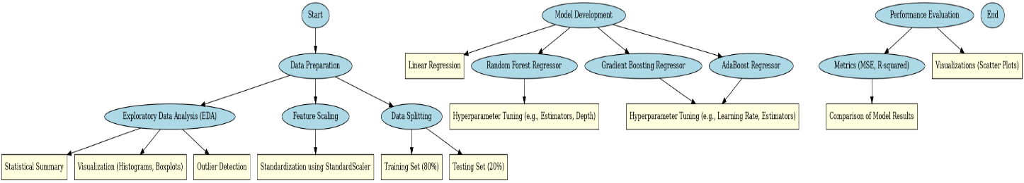
Figure 4 Flowchart of Methodology
To enhance its performance, Randomized Search CV, a method that efficiently explores a specified range of hyperparameter values, was employed for hyperparameter adjustments. The number of estimators, adjusted between 10 and 50, and the maximum depth of each tree, assessed within the specified range, were optimized (Vishnu et al., 2023).

3. Results
The study aimed to develop a predictive model to facilitate the diagnosis of cancer. The study aimed to develop a general model, which can be customized to analyze the cancer biomarkers of all cancer types. For this, we used multiple machine learning algorithms: Linear Regression, Random Forest Regression, AdaBoost, and Gradient Boosting Regressor. The analysis of 20 mouses and 49495 genes findings are as below. The data consisted of 21 columns: one target and the remaining containing gene expression values. The target column acted as a dependent variable while the gene expression values acted as independent variables. The data had 49495 genomic datasets divided into 20 independent variable sets and 1 dependent variable column. The dependent variable is further divided into 2 target values: 0,1. Target 0 represents a normal cell and 1 represents an affected cell. The target gene represented a cancerous and non-cancerous gene. At first, the data was subjected to thorough inspection to make sure that the data was clean. The data was cleaned to enhance the efficiency of a predictive model. The data was also analyzed for descriptive analysis to find the maximum and minimum values and to find the range of the data. The data was subjected to distribution analysis to find out the range of gene expression data.
The target 0 is a control group while the diseased cell has a minimum value of 1.75 and a maximum value of 14.2. The minimum range is from 1.75 to 1.98 while the maximum is from 13.92 to 14.02. There were no null values and it is suitable for machine learning prediction analysis. Later the data was divided into training data for the predictive model while the rest of the data was used for testing. 80% of the data was for training and 20% was for testing the model. The X data was divided into both testing and training data. The X training data had 39596 genomic data entries and 9899 no-null genomic data entries. The data was transformed to have a standard deviation of 1 and a mean value of 0. For this purpose, the data was standardized via scaler.fit_transform.
The cluster analysis of the data showed 2 prominent groups. This analysis was performed by using K-Means into 2 classes: X1. Cell & X2.Cell. The scatter graph in Figure 5 illustrates 2 distinct classes, in green and blue color. This analysis has clustered the healthy and diseased genes. The one in blue colors named cluster 0 is non-diseased while the one in green as represented by target1 is diseased or mutated genes. A correlation is evident between X1. Cell and X2. Cell and illustrates that the gene activity is correlated. Gene sample 11715101-s-at showed the highest value under target 1 and may act as a biomarker for cancer. While ERCC 00170-01_at illustrated a target 0 and has the lowest value. The scatterplot represents a clear stratification between blue and green datasets. This cluster analysis provides a strong baseline for identifying the cancerous and non-cancerous cells. It will help to identify the cancerous genes in any of the biological cases.
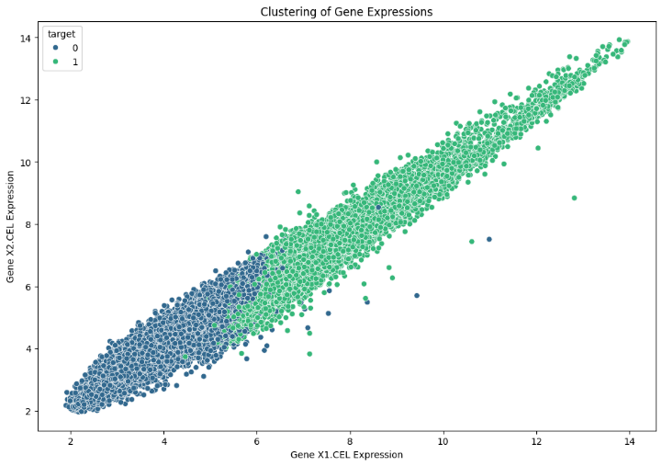

Figure 5 Cluster analysis of the non-cancerous and cancerous genes.
The data was analyzed by four models: Linear Regression, Random Forest Regressor, Gradient Boosting Regressor, and AdaBoost Regressor. The Linear regression analysis showed that the model can be utilized for the prediction of cancerous cells. The lower Mean Square Error value of 0.0724 as shown in Figure 6 indicates that the model has better efficiency in prediction.
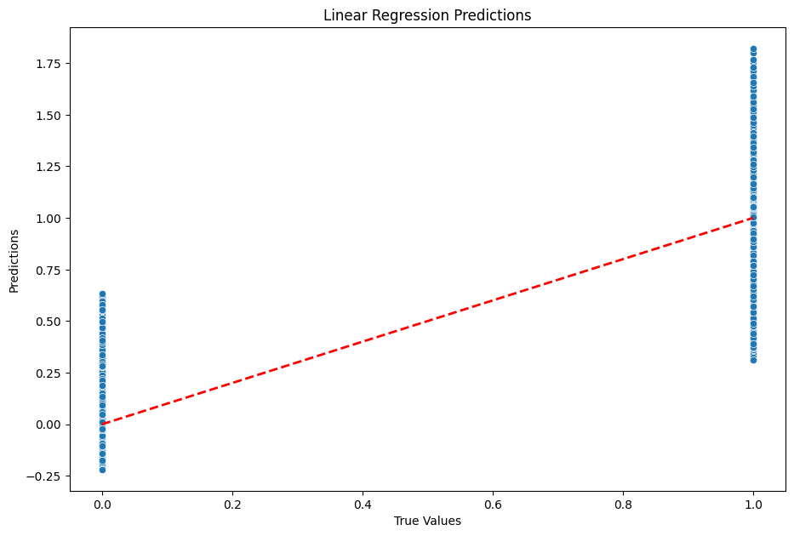
Figure 6 Linear Regression Analysis for Predictive Model
This model has an average fit for prediction. The R-square value exhibits a 69.84% variance. Thus, this model is perfect for linear regression prediction. However, it cannot be used for complex datasets.
The Random Forest had built multiple decision trees and it has shown very low error. The Mean Square error of 0.0040 makes it significant for building and developing predictive models. The predictive model with an R square (0.9833) value under the Random Forest ensemble makes it an excellent fit for machine learning prediction as shown in Figure 7.

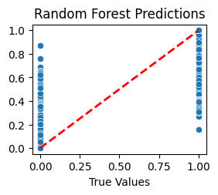

Figure 7 Random Forest Predictions for developing Predictive Model
Gradient Boosting of the data also provided another ensemble method for developing a prediction model in Python. Although its Mean Squared Error value was low but the R-square value made it a good choice for building a prediction model as shown in Figure 8.
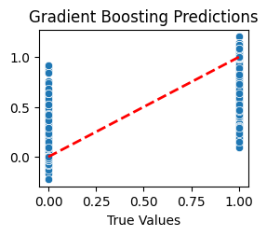
Figure 8 Gradient Boosting Predictions for developing Prediction Model
The last model AdaBoost regressor adjusted the weak genomic values and the R-square values represented a high variance value of 0.963 as shown in Figure 9.
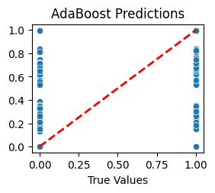
Figure 9 AdaBoost Predictions for developing Prediction Model
The results and R values show that the combination of all 4 models or any model can be deployed to develop the prediction model for diagnosis of cancerous genomic expressions.

4. Discussion
The integration of genomic expression signatures with computational analysis is a new advancement in cancer analysis. Although there are many limitations in this integration the ability of predictive models to detect cancer is a reliable technology. It helps in early cancer diagnosis as compared to traditional methods. This study can help to provide a baseline for developing actionable diagnostic tools. The advancement in machine learning including Random Forests, Support Vector Machine, and AdaBoost does not only facilitate the diagnosis but also helps to understand cancer detection at the genomic level.
Cohen et al. (2025) developed a prediction model for the detection of cancer using genomic data from 300 tumor classes. The study deployed Random Forest and regression analysis, similar to our study for cancer diagnosis. The model helped to detect the mutation and gene amplification. (Wang et al., 2024a) conducted a study for developing a predictive model by using a regression analysis model. The integration of regression analysis was similar to our study and their study helped in predicting liver cancer.
Awan et al. (2024) deployed logistic regression, support vector machine. K nearest classifier and random forest classifier to develop a predictive model to predict the base cancer. Their methodology was similar to our methodology. However, their training data was 70% and testing data was set to be 30%. In their predictive model, logistic regression analysis better predicted breast cancer. It also better supported K's nearest Neighbor and random forest in developing the model. (Hossin et al., 2023) also conducted a similar study to develop a predictive model for breast cancer detection. In this study, the author employed multiple machine-learning algorithms for cancer cell detection. He deployed logistic regression, decision tree classifier, K nearest neighbor, and support vector machine for breast cancer genomic sequence detection. This study is in concordant with our study. Hossin et al. (2023) also deployed the Gradient Boost classifier and AdaBoost classifier on the Wisconsin dataset for breast tumor detection. The study results also exhibited that Logistic regression gave an accuracy of 99.1%.
The algorithm that showed an accuracy of 98.3% is Random Forest Prediction which is also supported by (Dang). The study by (Dang) found that Random Forest showed accuracy with an R-square value of 0.978. The study also used the combination of Logistic Regressor, Decision Tree, and Random Forest for developing a predictive model. Ramroach et al. (2020) used different algorithms to study cancer classification for machine learning. This study aimed to optimize the drug's impact on cancer cells. The author used Random Forest, Gradient Boosting machine, and Neural Network for cancer classification. Neural Network reported the highest accuracy in their study. However, in contrast our study showed Random Forest algorithm to be the most accurate one.
Lyu and Haque (2018) also developed a predictive model using Linear regression, Random Forest, and Support Vector Machine for convolutional neural network layers development. Bahad and Saxena (2020) conducted a study that developed a predictive model using AdaBoost and the Gradient Boosting Regression algorithm. They found that Gradient Boosting has higher accuracy in developing a predictive model. However, AdaBoost was a good option for data classification. They validated their data by conducting a study on diabetes data. The finding of Gradient Boosting Ensemble to be higher is similar to our study. We have also concluded that AdaBoost ensemble can be utilized for weaker data classification.
Bhattacharjee et al. (2022) developed a model that combined Random Forest and Adaptive Boosting Gradient and found the accuracy of the model to be 97.97%. This model was specifically used for cancer diagnosis. Using predictive models to diagnose cancer is a novel approach to address the increasing number of cancer cases. The early diagnosis of cancer will help significantly to direct the treatment methods. It can help to avoid unnecessary clinical interventions.

5. Conclusion
The study was conducted to develop a predictive model that combines different algorithms for cancer detection. We deployed four different methods; Logistic Regression, Random Forest, Gradient Boosting ensemble, and AdaBoost ensemble. Random Forest proved to have higher efficacy and accuracy in predicting cancer. Moreover, the study also provided a baseline for developing a general cancer prediction model that can be customized for different cancer types. The study can be further enhanced to develop predictive models by integrating IoT sensors with different machine-learning algorithms. Further, the study can be enhanced by involving demographic, geographic, and different treatment techniques.
Acknowledgment
I acknowledge my respected supervisor, Dr. Cassy Ross for regular meetings and sparing precious time for long discussion on my research project. I also acknowledge Mosh (the python tutor on YouTube) and Harry (codes with harry series) for making informative videos to learn basics of prediction models.
Appendices
Declaration of Generative AI Use
Endnote
I used Generative AI tool Endnote for citations in my project for references. It saved a lot my time instead of using manual references. I used this tool in text and last section, references. Automated reference styles did not make author understandable the nature of work included in the references. By including this statement in my assessment submission, I attest that the information provided in this Originality and use of AI Declaration Statement is accurate and complete to the best of my knowledge. I understand that providing false information is a violation of the University’s Academic Misconduct Regulations and may result in academic and/or disciplinary consequences.

References
ADIR, O., POLEY, M., CHEN, G., FROIM, S., KRINSKY, N., SHKLOVER, J., SHAINSKY‐ROITMAN, J., LAMMERS, T. & SCHROEDER, A. J. A. M. 2020. Integrating artificial intelligence and nanotechnology for precision cancer medicine. 32, 1901989.
AHLUWALIA, P., KOLHE, R. & GAHLAY, G. K. J. B. E. B. A.-R. O. C. 2021. The clinical relevance of gene expression based prognostic signatures in colorectal cancer. 1875, 188513.
ALHARBI, F. & VAKANSKI, A. J. B. 2023. Machine learning methods for cancer classification using gene expression data: A review. 10, 173.
ALLEGRA, C., ANDREA, D. & IOLE, I. Radiomics in breast cancer classification and prediction. Seminars Cancer Biology; Academic Press: Cambridge, MA, USA, 2020.
ALLOGHANI, M., AL-JUMEILY, D., ALJAAF, A. J., KHALAF, M., MUSTAFINA, J. & TAN, S. Y. The application of artificial intelligence technology in healthcare: a systematic review. International conference on applied computing to support industry: Innovation and technology, 2019. Springer, 248-261.
ALSHEHRI, S., IMAM, S. S., RIZWANULLAH, M., AKHTER, S., MAHDI, W., KAZI, M. & AHMAD, J. J. P. 2020. Progress of cancer nanotechnology as diagnostics, therapeutics, and theranostics nanomedicine: preclinical promise and translational challenges. 13, 24.
ARORA, I. & TOLLEFSBOL, T. O. J. M. 2021. Computational methods and next-generation sequencing approaches to analyze epigenetics data: profiling of methods and applications. 187, 92-103.
AVANZO, M., TRIANNI, A., BOTTA, F., TALAMONTI, C., STASI, M. & IORI, M. J. A. S. 2021. Artificial intelligence and the medical physicist: welcome to the machine. 11, 1691.
AWAN, M. Z., ARIF, M. S., ABIDEEN, M. Z. U., ABODAYEH, K. J. I. J. O. E. E. & SCIENCE, C. 2024. Comparative analysis of machine learning models for breast cancer prediction and diagnosis: A dual-dataset approach. 34, 2032-2044.
AZIZAN, S., CHENG, K. J., MOHAMED, E. H. M., IBRAHIM, K., FARUQU, F. N., VELLASAMY, K. M., KHONG, T. L., SYAFRUDDIN, S. E. & IBRAHIM, Z. A. J. G. 2024. Insights into the molecular mechanisms and signalling pathways of epithelial to mesenchymal transition (EMT) in colorectal cancer: a systematic review and bioinformatic analysis of gene expression. 896, 148057.
BAHAD, P. & SAXENA, P. Study of adaboost and gradient boosting algorithms for predictive analytics. International Conference on Intelligent Computing and Smart Communication 2019: Proceedings of ICSC 2019, 2020. Springer, 235-244.
BHATTACHARJEE, A., MURUGAN, R., SONI, B., GOEL, T. J. P. & MEDICINE, E. S. I. 2022. Ada-gridrf: A fast and automated adaptive boost based grid search optimized random forest ensemble model for lung cancer detection. 45, 981-994.
BHONDE, S. B. & PRASAD, J. R. Deep Learning Techniques in Cancer Prediction Using Genomic Profiles. 2021 6th International Conference for Convergence in Technology (I2CT), 2021. IEEE, 1-9.
CAO, S., ZENG, Y., YANG, S. & CAO, S. Research on Python data visualization technology. Journal of physics: Conference series, 2021. IOP Publishing, 012122.
CASTRO, O., BRUNEAU, P., SOTTET, J.-S. & TORREGROSSA, D. J. A. C. S. 2023. Landscape of High-Performance Python to Develop Data Science and Machine Learning Applications. 56, 1-30.
CHAKRAVARTY, D. & SOLIT, D. B. J. N. R. G. 2021. Clinical cancer genomic profiling. 22, 483-501.
CHAUDHURI, A., KUMAR, D. N., DEHARI, D., PATIL, R., SINGH, S., KUMAR, D. & AGRAWAL, A. K. J. C. 2023. Endorsement of TNBC biomarkers in precision therapy by nanotechnology. 15, 2661.
CHEN, C., WANG, J., PAN, D., WANG, X., XU, Y., YAN, J., WANG, L., YANG, X., YANG, M. & LIU, G. P. J. M. 2023a. Applications of multi‐omics analysis in human diseases. 4, e315.
CHEN, P., WU, L. & WANG, L. J. A. S. 2023b. AI fairness in data management and analytics: A review on challenges, methodologies and applications. 13, 10258.
CHEN, S., SHI, X., LIU, S., PEI, P., YANG, K. & HU, L. J. J. O. I. M. 2024. Advancements in colorectal cancer detection: The role of immuno‐positron emission tomography, immuno‐single‐photon emission computed tomography, and machine learning applications.
CHU, X., ZHANG, B., KOEKEN, V. A., GUPTA, M. K. & LI, Y. J. F. I. I. 2021. Multi-omics approaches in immunological research. 12, 668045.
ÇINAR, Z., NUHU, A., ZEESHAN, Q., KORHAN, O., ASMAEL, M. & SAFAEI, B. 2020. Machine Learning in Predictive Maintenance towards Sustainable Smart Manufacturing in Industry 4.0, Sustainability, 12, 9, 1-42.
COHEN, G. B., YAACOV, A., ZVI, Y. B., LOUTATI, R., LISHINSKY, N., LANDAU, J., HOPE, T., POPOVZTER, A., ROSENBERG, S. J. C. I. B. & MEDICINE 2025. Graph convolution networks model identifies and quantifies gene and cancer specific transcriptome signatures of cancer driver events. 185, 109491.
DAMYANOV, C., MASLEV, I., PAVLOV, V. & AVRAMOV, L. J. A. C. A. M. 2018. Conventional treatment of cancer realities and problems. 1, 1-9.
DANG, A. Cancer Prediction using Machine Learning Algorithms.
DE FELICE, F. & POLIMENI, A. J. I. V. 2020. Coronavirus disease (COVID-19): a machine learning bibliometric analysis. 34, 1613-1617.
DE VRIES, N. L., MAHFOUZ, A., KONING, F. & DE MIRANDA, N. F. J. F. I. O. 2020. Unraveling the complexity of the cancer microenvironment with multidimensional genomic and cytometric technologies. 10, 1254.
DELLI PIZZI, A., CHIARELLI, A. M., CHIACCHIARETTA, P., D’ANNIBALE, M., CROCE, P., ROSA, C., MASTRODICASA, D., TREBESCHI, S., LAMBREGTS, D. M. J. & CAPOSIENA, D. J. S. R. 2021. MRI-based clinical-radiomics model predicts tumor response before treatment in locally advanced rectal cancer. 11, 5379.
DHILLON, S. K., GANGGAYAH, M. D., SINNADURAI, S., LIO, P. & TAIB, N. A. J. D. 2022. Theory and practice of integrating machine learning and conventional statistics in medical data analysis. 12, 2526.
DISNEY, M. D., SURESH, B. M., BENHAMOU, R. I. & CHILDS-DISNEY, J. L. J. C. O. I. C. B. 2020. Progress toward the development of the small molecule equivalent of small interfering RNA. 56, 63-71.
DOGAN, A. & BIRANT, D. J. E. S. W. A. 2021. Machine learning and data mining in manufacturing. 166, 114060.
FAN, T., LU, Z., LIU, Y., WANG, L., TIAN, H., ZHENG, Y., ZHENG, B., XUE, L., TAN, F. & XUE, Q. J. F. I. I. 2021. A novel immune-related seventeen-gene signature for predicting early stage lung squamous cell carcinoma prognosis. 12, 665407.
GALOȘ, D., GORZO, A., BALACESCU, O. & SUR, D. J. C. 2022. Clinical applications of liquid biopsy in colorectal cancer screening: current challenges and future perspectives. 11, 3493.
GIULIANO, A. E., CONNOLLY, J. L., EDGE, S. B., MITTENDORF, E. A., RUGO, H. S., SOLIN, L. J., WEAVER, D. L., WINCHESTER, D. J. & HORTOBAGYI, G. N. J. C. A. C. J. F. C. 2017. Breast cancer—major changes in the American Joint Committee on Cancer eighth edition cancer staging manual. 67, 290-303.
GLATZER, M., PANJE, C. M., SIRÉN, C., CIHORIC, N. & PUTORA, P. M. J. O. 2020. Decision making criteria in oncology. 98, 370-378.
HE, Z., CHEN, Z., TAN, M., ELINGARAMI, S., LIU, Y., LI, T., DENG, Y., HE, N., LI, S. & FU, J. J. C. P. 2020. A review on methods for diagnosis of breast cancer cells and tissues. 53, e12822.
HEITZER, E., HAQUE, I. S., ROBERTS, C. E. & SPEICHER, M. R. J. N. R. G. 2019. Current and future perspectives of liquid biopsies in genomics-driven oncology. 20, 71-88.
HENSON, K. E., ELLISS-BROOKES, L., COUPLAND, V. H., PAYNE, E., VERNON, S., ROUS, B. & RASHBASS, J. J. I. J. O. E. 2020. Data resource profile: national cancer registration dataset in England. 49, 16-16h.
HOSSIN, M. M., SHAMRAT, F. J. M., BHUIYAN, M. R., HIRA, R. A., KHAN, T., MOLLA, S. J. B. O. E. E. & INFORMATICS 2023. Breast cancer detection: an effective comparison of different machine learning algorithms on the Wisconsin dataset. 12, 2446-2456.
HUANG, J., BAI, X., QIU, Y. & HE, X. J. F. I. O. 2024. Application of AI on cholangiocarcinoma. 14, 1324222.
HUANG, S., YANG, J., FONG, S. & ZHAO, Q. J. C. L. 2020. Artificial intelligence in cancer diagnosis and prognosis: Opportunities and challenges. 471, 61-71.
IM, S.-A., LU, Y.-S., BARDIA, A., HARBECK, N., COLLEONI, M., FRANKE, F., CHOW, L., SOHN, J., LEE, K.-S. & CAMPOS-GOMEZ, S. J. N. E. J. O. M. 2019. Overall survival with ribociclib plus endocrine therapy in breast cancer. 381, 307-316.
KHALSAN, M., MACHADO, L. R., AL-SHAMERY, E. S., AJIT, S., ANTHONY, K., MU, M. & AGYEMAN, M. O. J. I. A. 2022. A survey of machine learning approaches applied to gene expression analysis for cancer prediction. 10, 27522-27534.
KHAN, M. F., GHAZAL, T. M., SAID, R. A., FATIMA, A., ABBAS, S., KHAN, M., ISSA, G. F., AHMAD, M., KHAN, M. A. J. C. I. & NEUROSCIENCE 2021. An IoMT‐Enabled Smart Healthcare Model to Monitor Elderly People Using Machine Learning Technique. 2021, 2487759.
KHANDAKAR, S., AL MAMUN, M. A., ISLAM, M. M., HOSSAIN, K., MELON, M. M. H., JAVED, M. S. J. E. A. T. & PRACTICE 2024. Unveiling early detection and prevention of cancer: Machine learning and deep learning approaches. 30, 14614-14628.
KHANDARE, A., AGARWAL, N., BODHANKAR, A., KULKARNI, A. & MANE, I. 2023. Analysis of python libraries for artificial intelligence. Intelligent Computing and Networking: Proceedings of IC-ICN 2022. Springer.
LA FORGIA, D., FANIZZI, A., CAMPOBASSO, F., BELLOTTI, R., DIDONNA, V., LORUSSO, V., MOSCHETTA, M., MASSAFRA, R., TAMBORRA, P. & TANGARO, S. J. D. 2020. Radiomic analysis in contrast-enhanced spectral mammography for predicting breast cancer histological outcome. 10, 708.
LATEEF, F., JAMAL, S., NASIR, S. J. J. O. T. C. O. P. & PAKISTAN, S. 2018. Her-2/neu oncogene amplification by fluorescence in situ hybridization and protein overexpression on immunohistochemistry in breast cancer. 28, 581-586.
LAVANYA, A., GAURAV, L., SINDHUJA, S., SEAM, H., JOYDEEP, M., UPPALAPATI, V., ALI, W. & SD, V. S. J. I. J. C. E. R. T. 2023. Assessing the performance of python data visualization libraries: a review. 10, 29-39.
LEJA, M., LINĒ, A. J. B. P. & GASTROENTEROLOGY, R. C. 2021. Early detection of gastric cancer beyond endoscopy-new methods. 50, 101731.
LOULERGUE, F. & PHILIPPE, J. New List Skeletons for the Python Skeleton Library. 2019 20th International Conference on Parallel and Distributed Computing, Applications and Technologies (PDCAT), 2019. IEEE, 392-397.
LYU, B. & HAQUE, A. Deep learning based tumor type classification using gene expression data. Proceedings of the 2018 ACM international conference on bioinformatics, computational biology, and health informatics, 2018. 89-96.
MASSARD, C., MICHIELS, S., FERTÉ, C., LE DELEY, M.-C., LACROIX, L., HOLLEBECQUE, A., VERLINGUE, L., ILEANA, E., ROSELLINI, S. & AMMARI, S. J. C. D. 2017. High-throughput genomics and clinical outcome in hard-to-treat advanced cancers: results of the MOSCATO 01 trial. 7, 586-595.
MATTOX, A. K., FAKHRY, C. & AGRAWAL, N. J. C. O. R. 2022. Biomarker-Based Evaluation of Treatment Response and Surveillance of HPV-Associated Squamous Cell Carcinoma. 10, 85-95.
MEDINA-LARA, A., GRIGORE, B., LEWIS, R., PETERS, J., PRICE, S., LANDA, P., ROBINSON, S., NEAL, R., HAMILTON, W. & SPENCER, A. E. J. H. T. A. 2020. Cancer diagnostic tools to aid decision-making in primary care: mixed-methods systematic reviews and cost-effectiveness analysis. 24, 1.
MOHAMMADI-SHEMIRANI, P., SOOD, T. & PARÉ, G. J. C. A. R. 2023. From ‘omics to multi-omics technologies: the discovery of novel causal mediators. 25, 55-65.
NABIPOUR, M., NAYYERI, P., JABANI, H., SHAHAB, S. & MOSAVI, A. J. I. A. 2020. Predicting stock market trends using machine learning and deep learning algorithms via continuous and binary data; a comparative analysis. 8, 150199-150212.
NAGTEGAAL, I. D., ODZE, R. D., KLIMSTRA, D., PARADIS, V., RUGGE, M., SCHIRMACHER, P., WASHINGTON, K. M., CARNEIRO, F. & CREE, I. A. J. H. 2019. The 2019 WHO classification of tumours of the digestive system. 76, 182.
NANCE, D., TOMOV, S. & WONG, K. A Python Library for Matrix Algebra on GPU and Multicore Architectures. 2022 IEEE 19th International Conference on Mobile Ad Hoc and Smart Systems (MASS), 2022. IEEE, 770-775.
NASSIF, A. B., TALIB, M. A., NASIR, Q., AFADAR, Y. & ELGENDY, O. J. A. I. I. M. 2022. Breast cancer detection using artificial intelligence techniques: A systematic literature review. 127, 102276.
NIKHIL, U. V., PANDIYAN, A. M., RAJA, S. & STAMENKOVIC, Z. J. C. 2024. Machine Learning-Based Crop Yield Prediction in South India: Performance Analysis of Various Models. 13, 137.
ODABAŞı, Ç., YıLDıRıM, R. J. S. E. M. & CELLS, S. 2020. Machine learning analysis on stability of perovskite solar cells. 205, 110284.
OH, S. E., CHOI, M.-G. & SEO, S. W. J. A. O. S. O. 2019. ASO author reflections: use of the survival recurrent network for prediction of overall survival in patients with gastric cancer. 26, 539-540.
PAI‐SCHERF, L., BLUMENTHAL, G. M., LI, H., SUBRAMANIAM, S., MISHRA‐KALYANI, P. S., HE, K., ZHAO, H., YU, J., PACIGA, M. & GOLDBERG, K. B. J. T. O. 2017. FDA approval summary: pembrolizumab for treatment of metastatic non‐small cell lung cancer: first‐line therapy and beyond. 22, 1392-1399.
PANJA, S., RAHEM, S., CHU, C. J. & MITROFANOVA, A. J. C. G. 2021. Big data to knowledge: application of machine learning to predictive modeling of therapeutic response in cancer. 22, 244.
PARK, J. H., MOON, J. H., KIM, H. J., KONG, M. H. & OH, Y. H. J. K. J. O. F. M. 2020. Sedentary lifestyle: overview of updated evidence of potential health risks. 41, 365.
PASCHKE, S., JAFAROV, S., STAIB, L., KREUSER, E.-D., MAULBECKER-ARMSTRONG, C., ROITMAN, M., HOLM, T., HARRIS, C. C., LINK, K.-H. & KORNMANN, M. J. I. J. O. M. S. 2018. Are colon and rectal cancer two different tumor entities? A proposal to abandon the term colorectal cancer. 19, 2577.
PATI, J. J. I. A. 2018. Gene expression analysis for early lung cancer prediction using machine learning techniques: An eco-genomics approach. 7, 4232-4238.
POON, M. T., KENI, S., VIMALAN, V., IP, C., SMITH, C., ERRIDGE, S., WEIR, C. J. & BRENNAN, P. M. J. N.-O. A. 2021. Extent of MGMT promoter methylation modifies the effect of temozolomide on overall survival in patients with glioblastoma: a regional cohort study. 3, vdab171.
POVEDA, A., DEL MURO, X. G., LÓPEZ-GUERRERO, J. A., CUBEDO, R., MARTÍNEZ, V., ROMERO, I., SERRANO, C., VALVERDE, C. & MARTÍN-BROTO, J. J. C. T. R. 2017. GEIS guidelines for gastrointestinal sarcomas (GIST). 55, 107-119.
QIAN, Y., DAZA, J., ITZEL, T., BETGE, J., ZHAN, T., MARMÉ, F. & TEUFEL, A. J. C. 2021. Prognostic cancer gene expression signatures: current status and challenges. 10, 648.
RAMROACH, S., JOSHI, A. & JOHN, M. J. M. O. 2020. Optimisation of cancer classification by machine learning generates an enriched list of candidate drug targets and biomarkers. 16, 113-125.
SAMALA, R. K., CHAN, H.-P., HADJIISKI, L., HELVIE, M. A., RICHTER, C. D. & CHA, K. H. J. I. T. O. M. I. 2018. Breast cancer diagnosis in digital breast tomosynthesis: effects of training sample size on multi-stage transfer learning using deep neural nets. 38, 686-696.
SARHADI, V. K. & ARMENGOL, G. J. B. 2022. Molecular biomarkers in cancer. 12, 1021.
SEBASTIAN, A. M. & PETER, D. J. L. 2022. Artificial intelligence in cancer research: trends, challenges and future directions. 12, 1991.
SHARMA, P., HU-LIESKOVAN, S., WARGO, J. A. & RIBAS, A. J. C. 2017. Primary, adaptive, and acquired resistance to cancer immunotherapy. 168, 707-723.
SIEGEL, R. L., MILLER, K. D., FUCHS, H. E. & JEMAL, A. J. C. A. C. J. F. C. 2021. Cancer statistics, 2021. 71, 7-33.
STANČIN, I. & JOVIĆ, A. An overview and comparison of free Python libraries for data mining and big data analysis. 2019 42nd International convention on information and communication technology, electronics and microelectronics (MIPRO), 2019. IEEE, 977-982.
STEFANOU, I. & DARVE, F. 2024. Machine Learning in Geomechanics 1: Overview of Machine Learning, Unervised Learning, Regression, Classification and Artificial Neural Networks.
SUN, Y., ZHANG, J. & ZHANG, Y. J. P. O. F. 2024. Adaboost algorithm combined multiple random forest models (Adaboost-RF) is employed for fluid prediction using well logging data. 36.
SUNG, H., FERLAY, J., SIEGEL, R. L., LAVERSANNE, M., SOERJOMATARAM, I., JEMAL, A. & BRAY, F. J. C. A. C. J. F. C. 2021. Global cancer statistics 2020: GLOBOCAN estimates of incidence and mortality worldwide for 36 cancers in 185 countries. 71, 209-249.
TAHA, B. A., KADHIM, A. C., ADDIE, A. J., HAIDER, A. J., AZZAHRANI, A. S., RAIZADA, P., RUSTAGI, S., CHAUDHARY, V. & ARSAD, N. J. M. J. 2024. Advancing cancer diagnostics through multifaceted optical biosensors supported by nanomaterials and artificial intelligence: A panoramic outlook. 111307.
VIDYA, M. & KARKI, M. V. Skin cancer detection using machine learning techniques. 2020 IEEE international conference on electronics, computing and communication technologies (CONECCT), 2020. IEEE, 1-5.
VILLA, C. & YOON, J. H. J. L. 2021. Multi-omics for the understanding of brain diseases. MDPI.
VILLEGAS-CH, W., ROMÁN-CAÑIZARES, M. & PALACIOS-PACHECO, X. J. A. S. 2020. Improvement of an online education model with the integration of machine learning and data analysis in an LMS. 10, 5371.
VIRZÌ, G. M., CLEMENTI, A., BATTAGLIA, G. G. & RONCO, C. J. C. M. 2019. Multi-omics approach: New potential key mechanisms implicated in cardiorenal syndromes. 9, 201-211.
VISHNU, M., RUPAK, V. V., VEDHAPRIYAA, S., SANGEETHA, M., MANJULADEVI, R. & SAGANA, C. Recurrent gastric cancer prediction using randomized search cv optimizer. 2023 International Conference on Computer Communication and Informatics (ICCCI), 2023. IEEE, 1-5.
WANG, T., LI, W., WU, Y., YOU, L., ZHENG, C., ZHANG, J., QU, L. & SUN, X. J. B. D. 2024a. Construction of a prognostic model based on disulfidptosis-related genes and identification of CCNA2 as a novel biomarker for hepatocellular carcinoma. 19, 128.
WANG, Y., ZHA, Y., LIU, L., LIAO, A., DONG, Z., ROBERTS, N. & LI, Y. J. J. O. T. I. M. 2024b. Single photon emission computed tomography/computed tomography imaging of gouty arthritis: A new voice. 12, 215-224.
WEI, Q., TAN, N., XIONG, S., LUO, W., XIA, H. & LUO, B. J. C. 2023. Deep learning methods in medical image-based hepatocellular carcinoma diagnosis: a systematic review and meta-analysis. 15, 5701.
WU, P., ZHENG, Y., WANG, Y., WANG, Y. & LIANG, N. J. J. O. T. M. 2020. Development and validation of a robust immune-related prognostic signature in early-stage lung adenocarcinoma. 18, 1-12.
ZIELINSKI, J. M., LUKE, J. J., GUGLIETTA, S. & KRIEG, C. J. F. I. I. 2021. High throughput multi-omics approaches for clinical trial evaluation and drug discovery. 12, 590742.

